Task: 1. Create an instance in the US-East-1 (N. Virginia) region with Linux OS and
manage the requirement of web servers of your company using AMI.
2. Replicate the instance in the US-West-2 (Oregon) region.
3. Build two EBS volumes and attach them to the instance in the US-East-1
(N. Virginia) region.
4. Delete one volume after detaching it and extend the size of the other
volume.
5. Take backup of this EBS volume.

Step1: Firstly we create one EC2 instance > login to AWS console > Search EC2 > Click on launch instance > Name = WebServer > Amazon Machine Image = Amazon Linux > Instance type = t3 Micro > Key pair = create new keypair > Keypair name = webserver keypair > keypair type = RSA > Private key file format = .pem > Click on create new pair > Network Setting > Firewall (security groups) = Create new security group > allow (ssh and http) > Storage = 8gb > user data = Click on launch instance.
Lauch instance
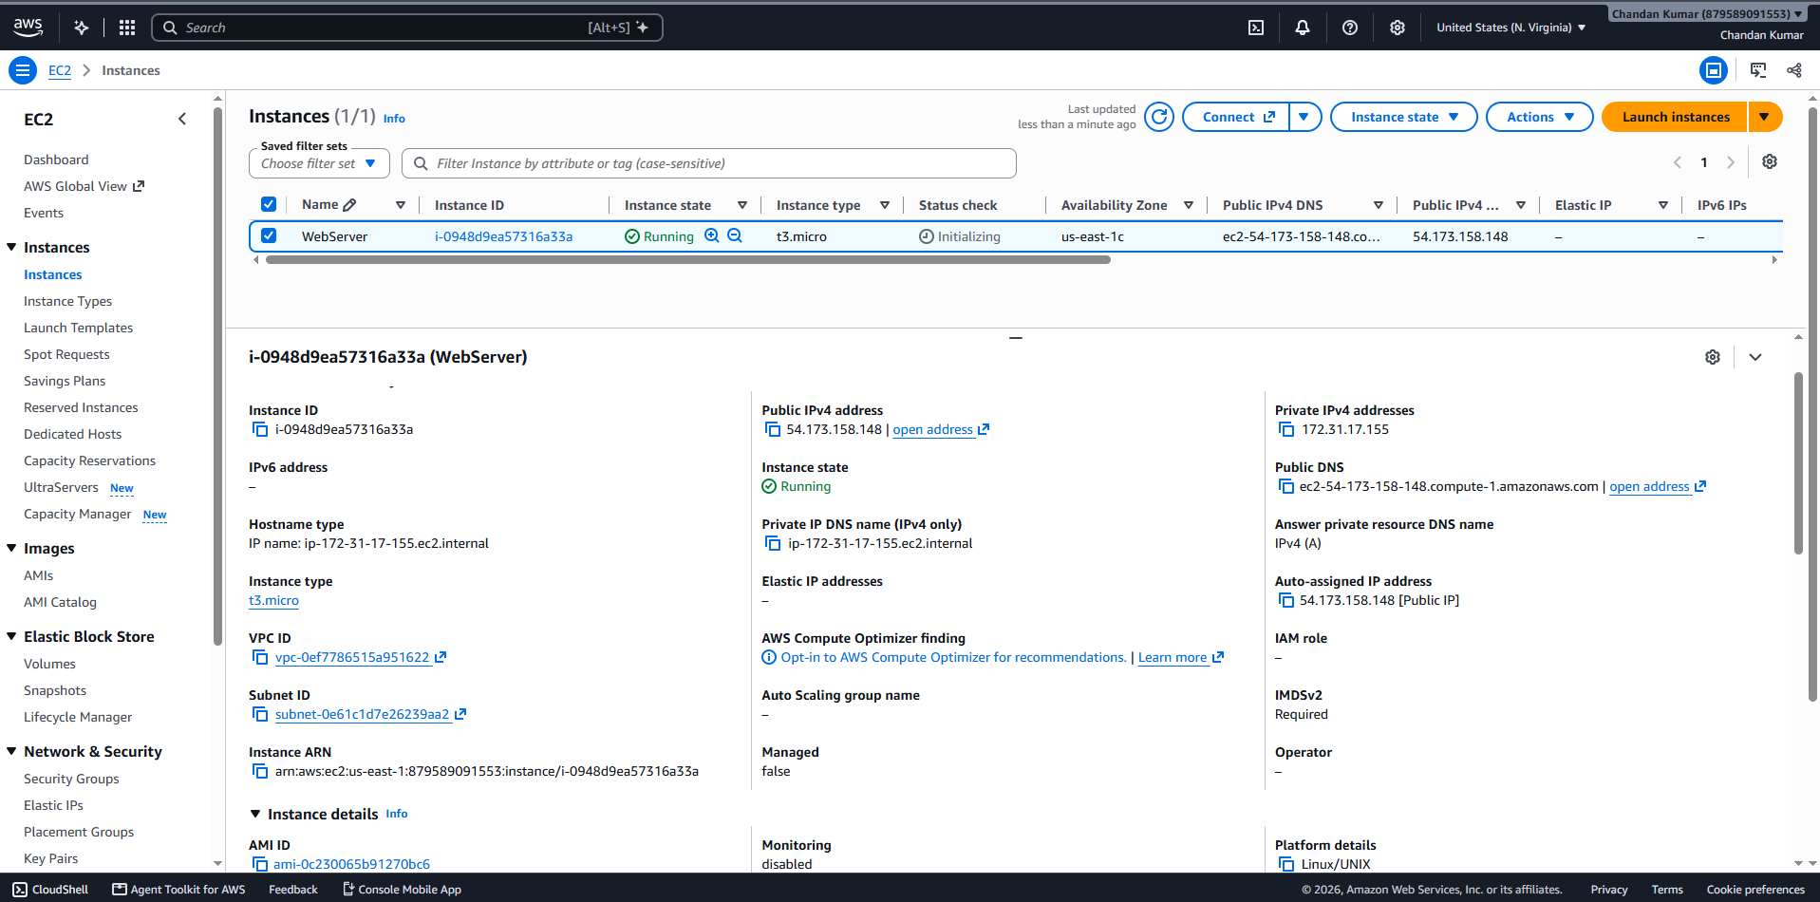
Step 2: Select ec2 > Actions > Image and templates > Create Image > Image name = AMI- Web Server> Click on create image.
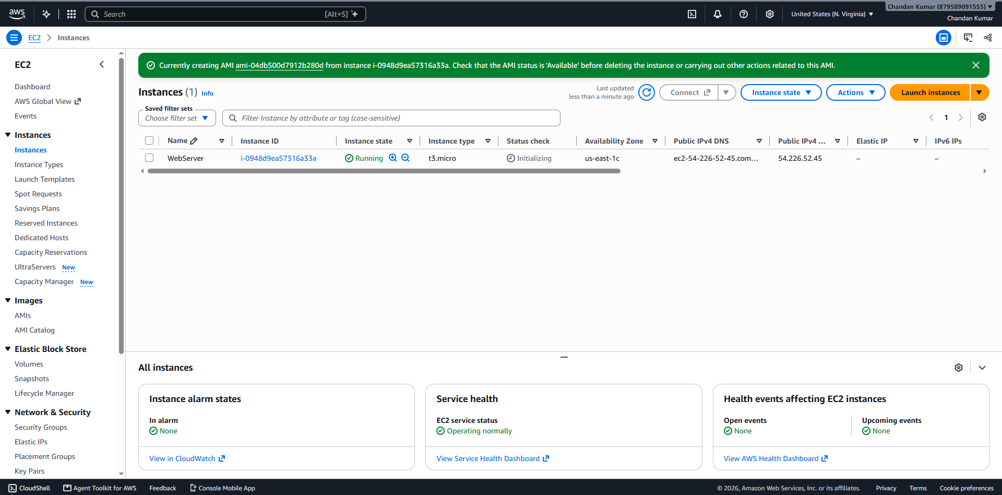
Step 3: Go to AMI > Select your AMI (AMI- Web Server) > Actions > copy AMI > AMI destination = AMI region > Destination region = Oregon > Copy AMI. > Go to Oregon region > Click on AMI > we see AMI will copy there.
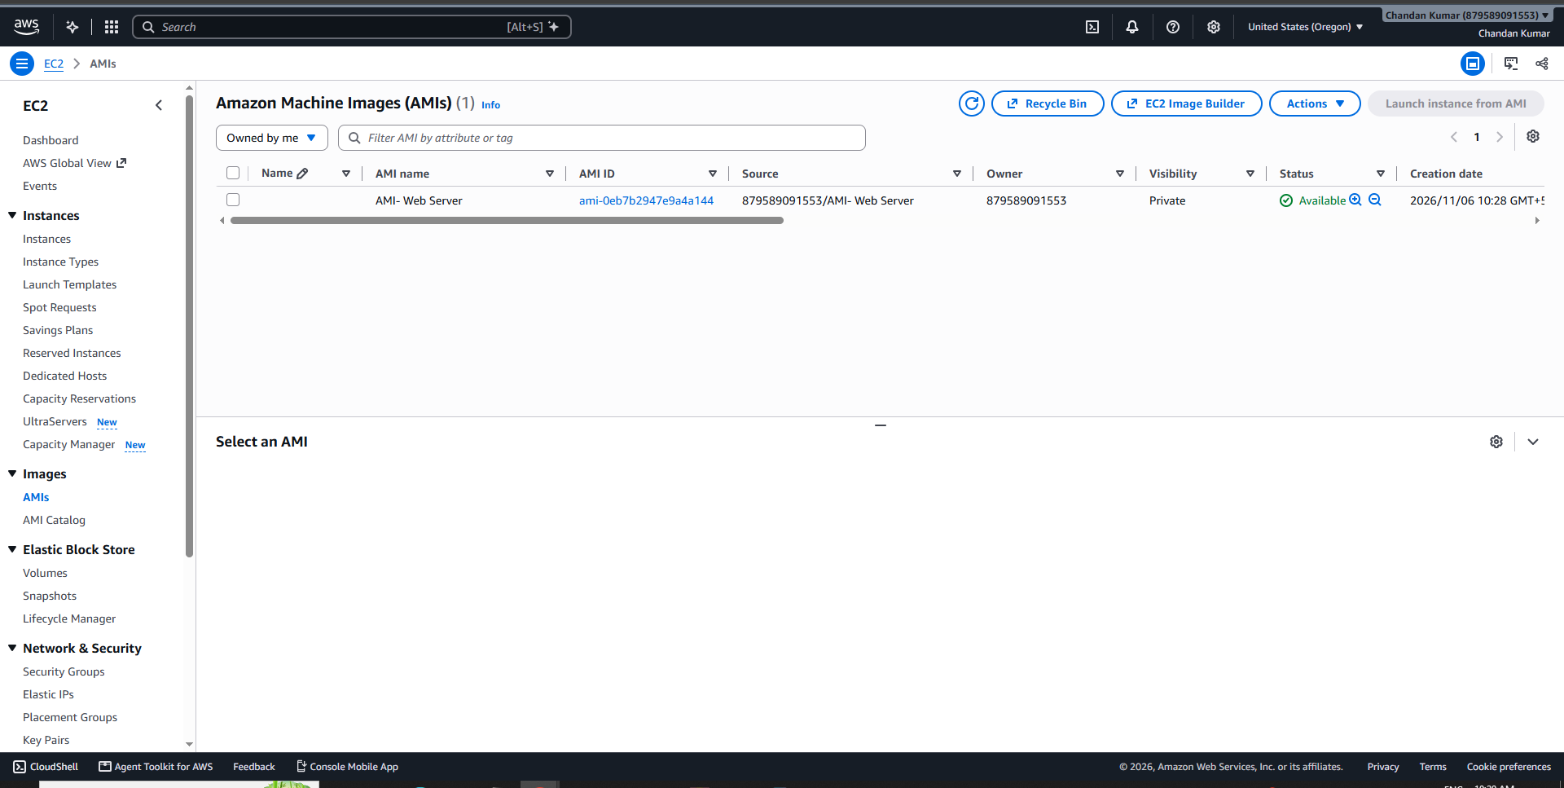
Step 4: Select AMI > Launch AMI from instance > Instance details > Name and tags > Name = Copy -WebServer > Instance type = t3 micro > key pair > create new key pair > Network Setting > Firewall (security groups) = Create new security group > allow (ssh and http) > Storage = 8gb > user data = Click on launch instance.
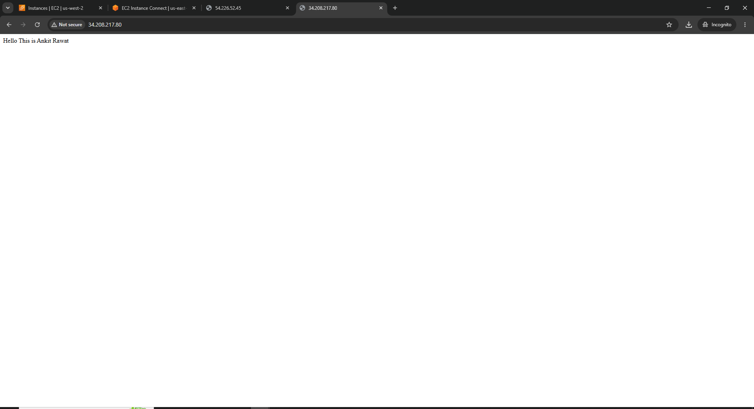
You we have two web servers in different AWS regions.
Step 5: In search > Elastic Block Storage > volumes > Create volume > size (5gb) >AZ= US-East-1c > Click on create volume .
Create another EBS volume > Elastic Block Storage > volumes > Create volume > size (5gb) > AZ= US-East-1c > Click on create volume .
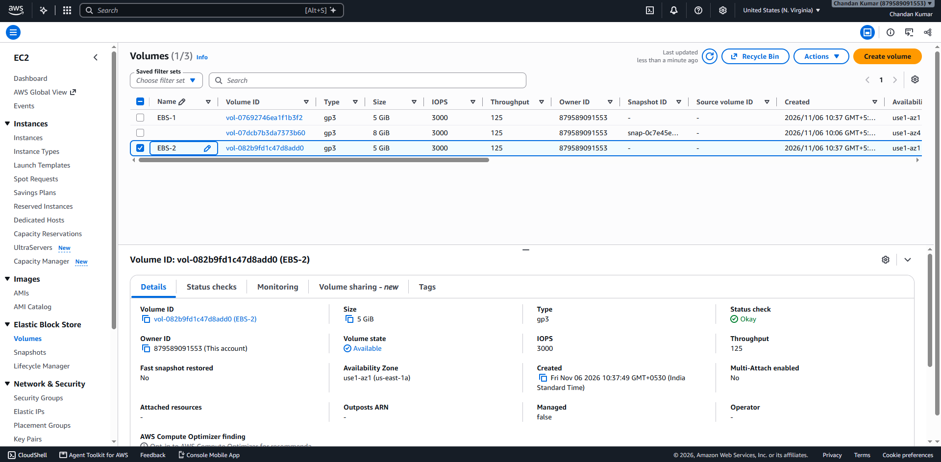
Step 6: Select volume > Action > attach volume > instance > select your web server instance > device name = /dev/sdb.
Select volume > Action > attach volume > instance > select your web server instance > device name = /dev/sdc.
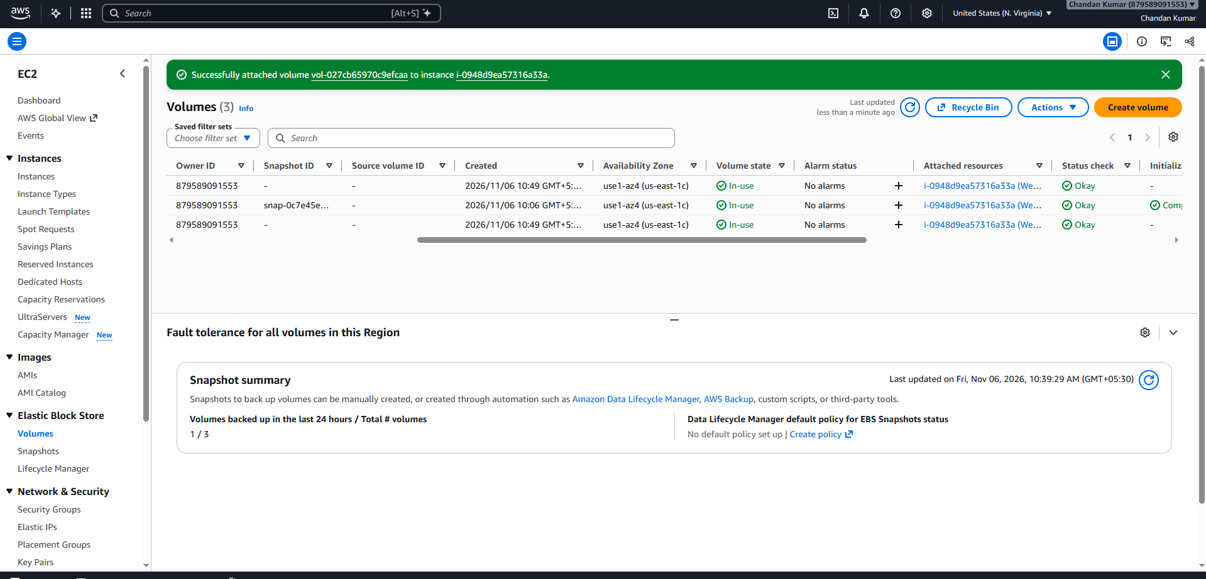
Step 7: Mount EBS volumes on amazon linux > sudo mkfs -t xfs /dev/nvme1n1 > sudo mkfs -t xfs /dev/nvme2n1 > sudo mkdir /data1 > sudo mkdir /data2 > sudo mount /dev/nvme1n1 /data1 > sudo mount /dev/nvme2n1 /data2 > sudo touch /data1/file1.txt > sudo touch /data2/file2.txt > ls -l /data1 > ls -l /data2

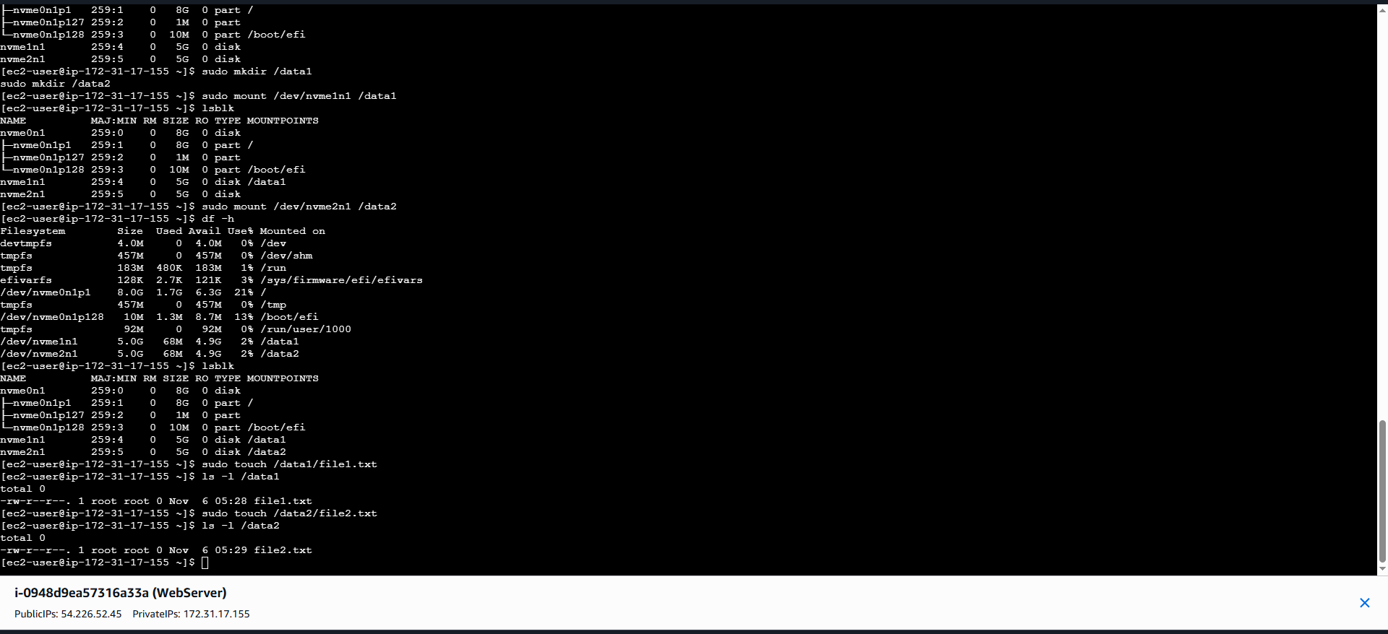
Step 8: type > sudo umount /data1 > lsblk
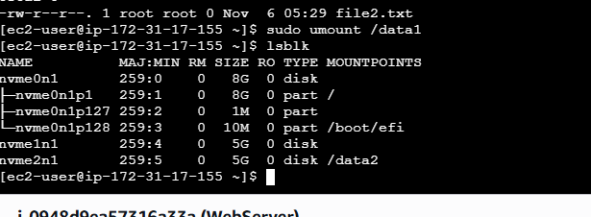
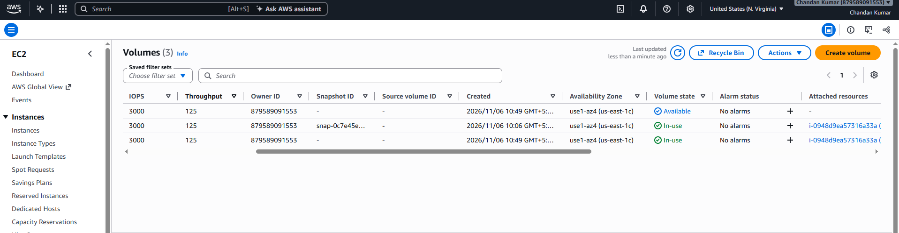
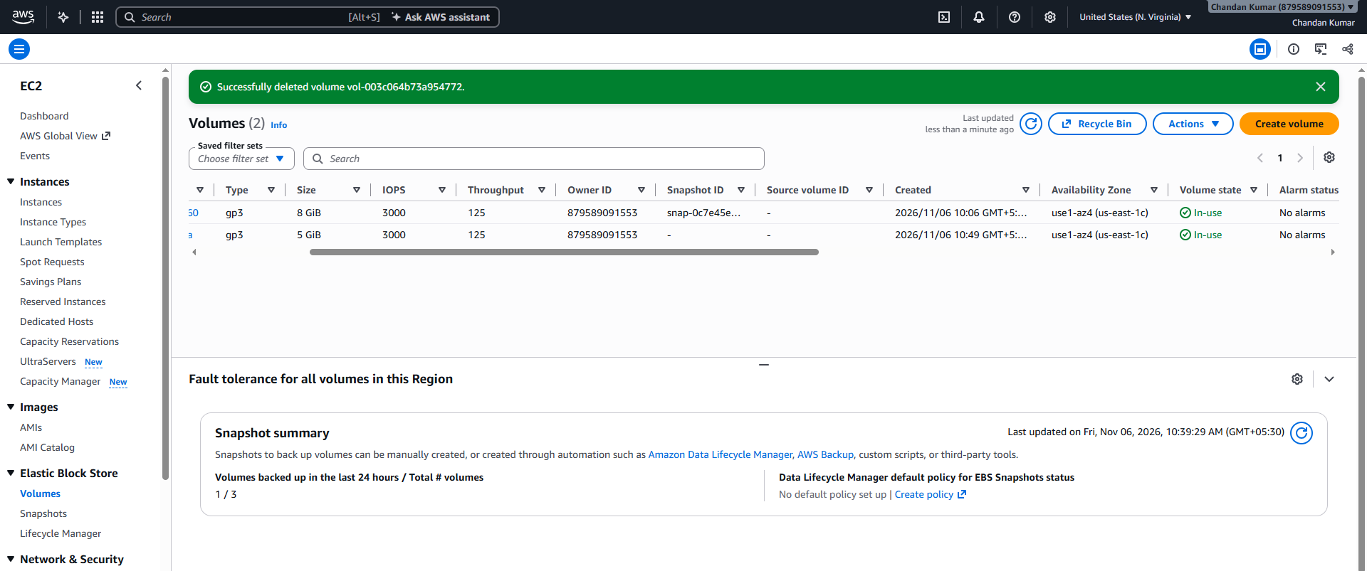
Step 9: Select volume > modify volume > size = 6gb .
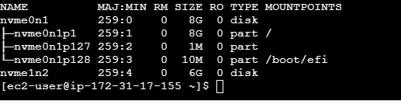
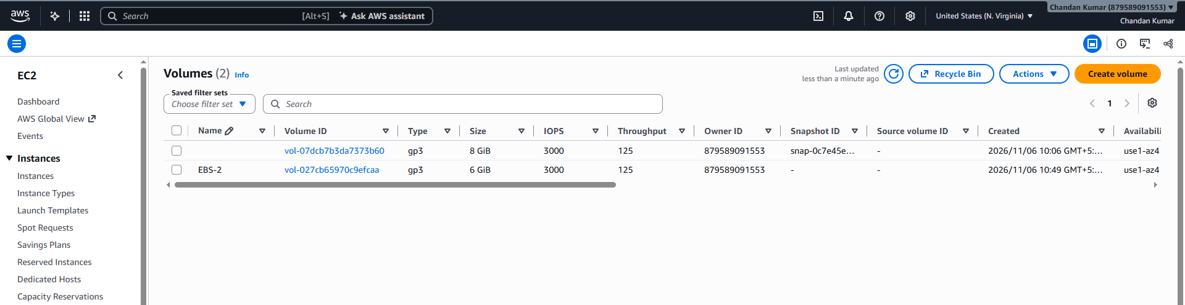
Step 10: Select volume (6gib)> actions > Create snapshot > EBS volume snapshot = name(EBS volume snapshot) > click on create snapshot.


